Report on the “Lecture on Career Counseling”

Event Date: 23rd November, 2022

Event Venue: Babbar Karam Singh Shaheed Government co-education Senior Secondary School, Village Haripur.

Organising unit/ agency/ collaborating agency: UICM (University Institute of Commerce and Management)

Name of the Event: “Lecture on Career Counseling”

Number of students participated in activity: 60

Summary of Report:

The Department of Management and Hotel Management of University Institute of Commerce and Management, Sant Baba Bhag Singh University, Jalandhar has organized “Lecture on Career Counseling” 23rd November, 2022.

Ms. Inderpreet Kaur, COD Management was the Resource Person of the day. The lecture was basically for the students of classes 11th and 12th .She introduced students to various courses of science, commerce and arts as the basics and then she explained students the sea of opportunities in the outer world.

In the last session Principal of the School appreciated the efforts of the Ms. Inderpreet Kaur for sharing her valuable knowledge and expertise with the students.

Glimpse of the Event:

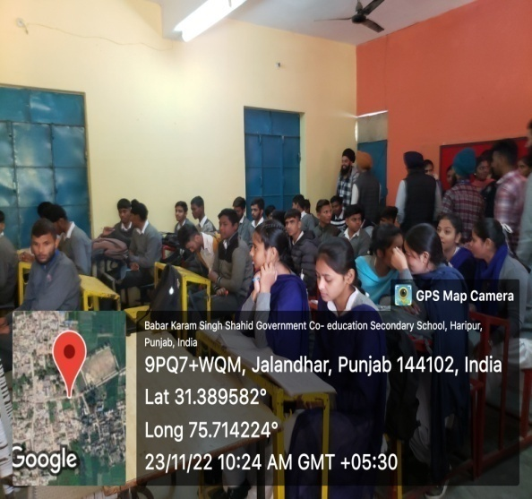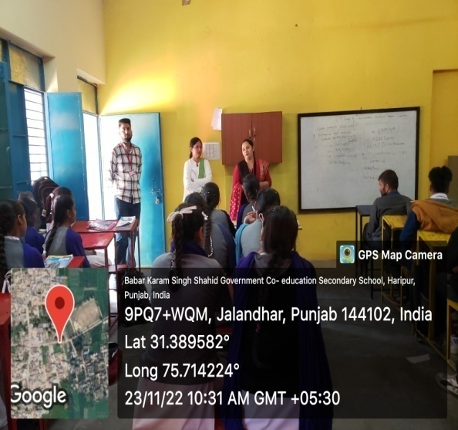

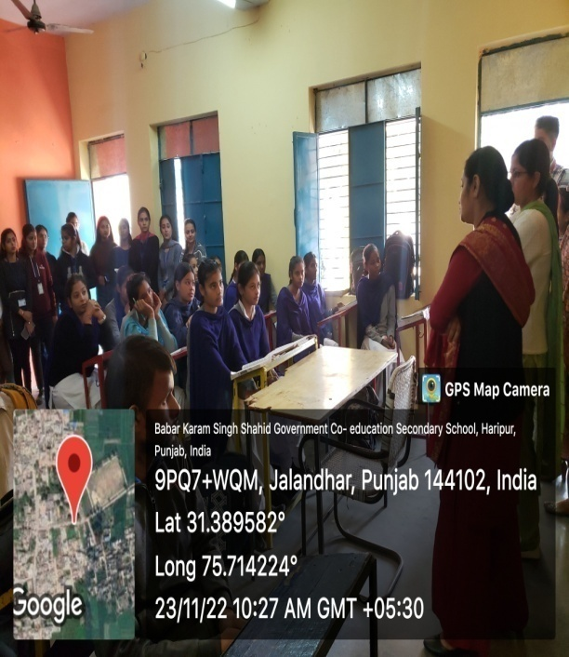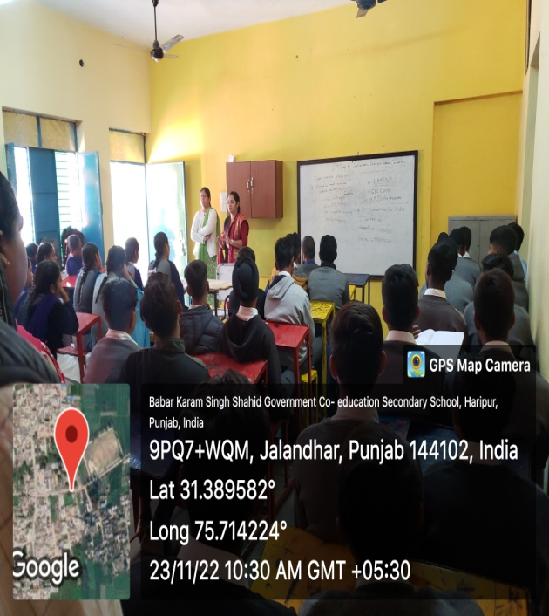

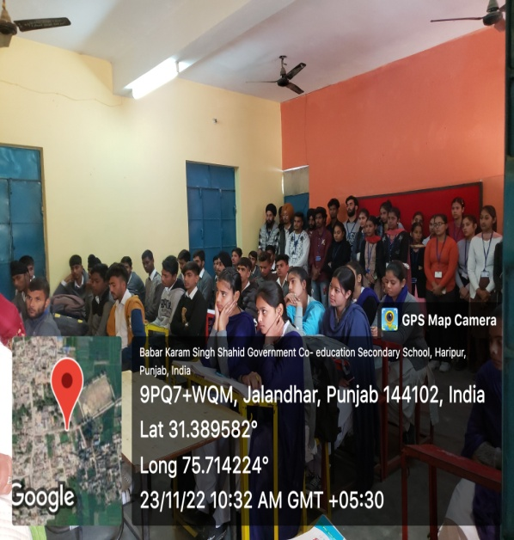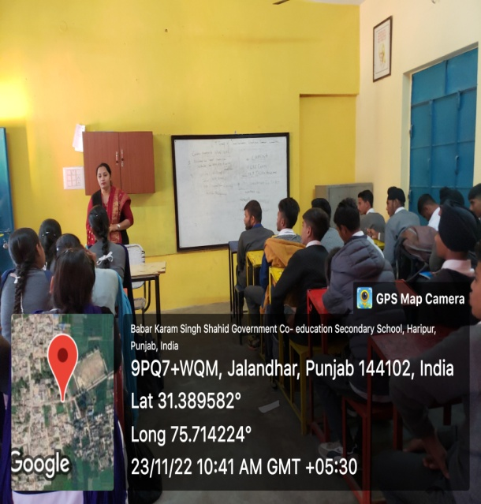

Activity In charge COD Dean Institute

